#CREATE JENKINS JOB FOR INSTTAL HTTPD SERVER/DEPLOY

STEP-1:cerate jenkins job:

1-log in to jenkins.

2-click "new item"on the jenkins dashboard.

3-choose "freestyle project"and name the job (e.g. httpd-job).

4-click "ok"

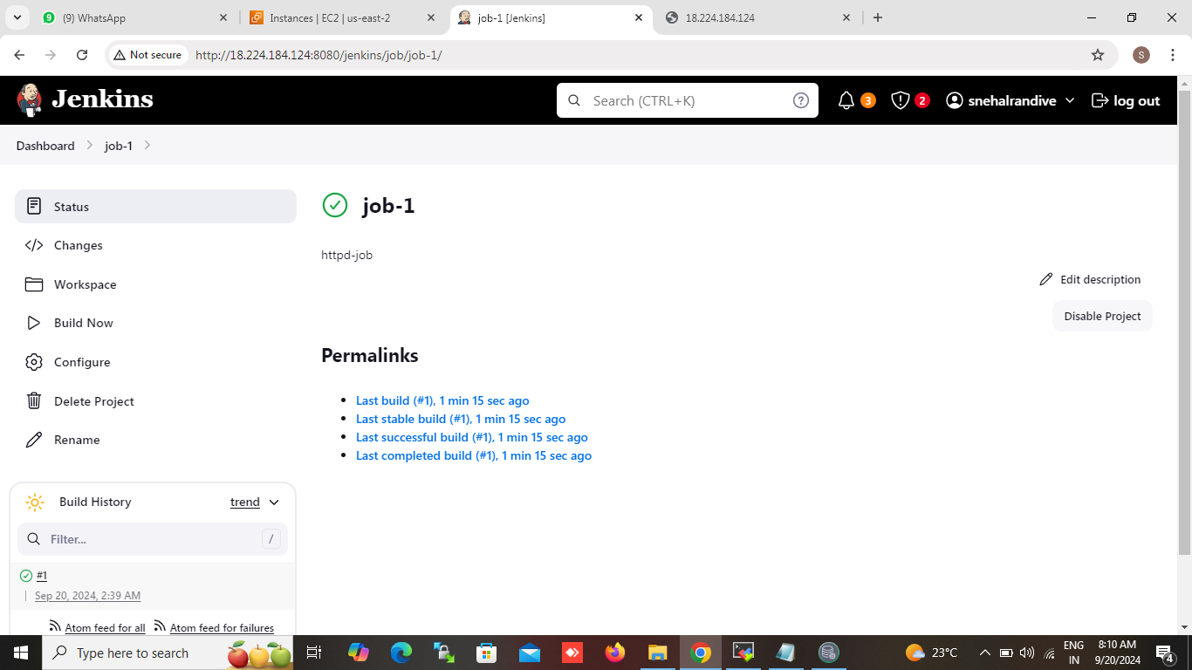

STEP-2:configure the job:

1-in the job configuration page ,scrool down to "Build" section.

2-click "add Build step" and choose "Execute shell".

3-in the command box enter the script.

STEP-3:write the script

#!/bin/bash

# install httpd

sudo yum install httpd -y

# start httpd service

sudo service httpd start

# give parmission

sudo chmod -R 777 /var/www/html/

# add containt in file

echo "hello world" >> /var/www/html/index.html

# restart service httpd

sudo service httpd restart

# SAVE AND TRIGGER THE JOB

#STEP-4: 1-save the job configuration

2-click"Build now"to trigger the job.

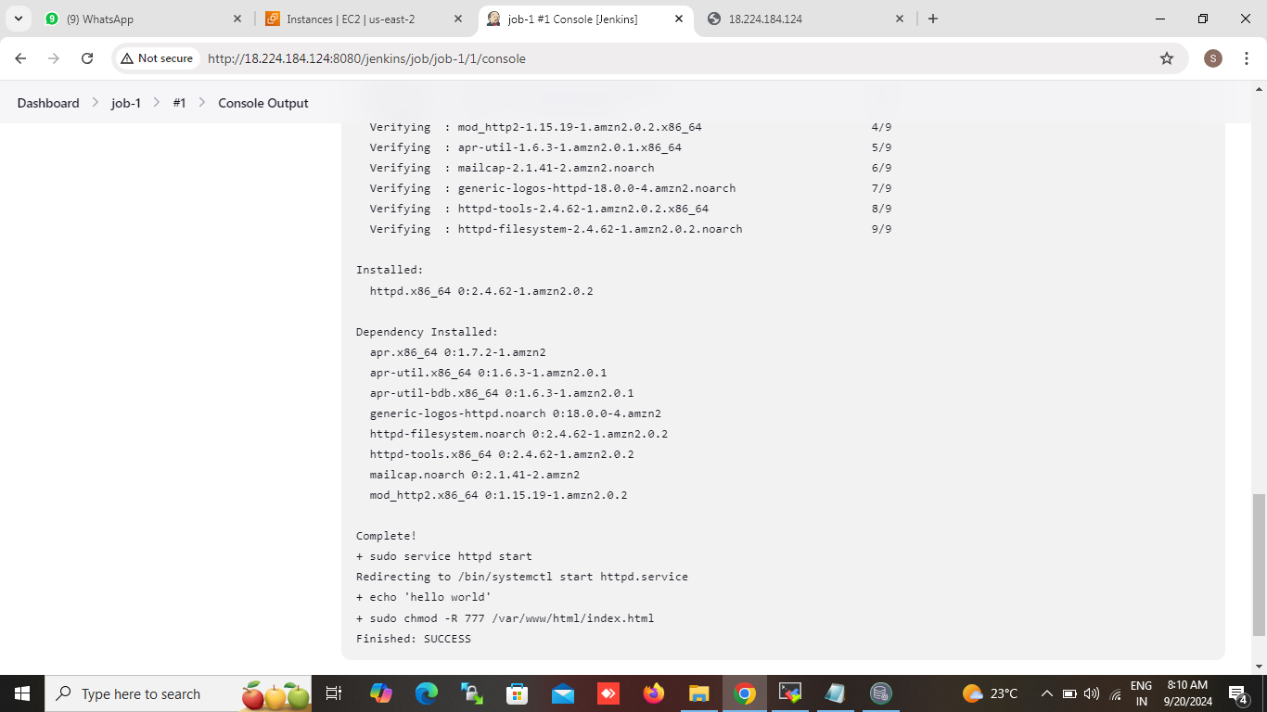

# FOR JENKINS PIPELINE JOB

pipeline{

agent any

stages{

stage("install httpd"){

steps{

sh 'suo yum install httpd -y'

sh'sudo service httpd start'

sh'sudo chmod -R 777 /var/www/html

sh'echo "hello all" >>/var/www/html/index.html

sh'service httpd restart'

}

}

}

}